Section A (70 marks) Answer all questions in this section
1.a. B (1 mark)
b) Parallax error. This is the error originating from poor positioning of the eye (2 marks)
c)
$\frac{10}{100} ×11.1$
═ 1.11 (1)
Actual value ═ observed – error
=11.1 - 1.11 (1)
= 9.99 ml (1) (3 marks)
- -Repeating the experiment (1)
-Using well calibrated instruments(1)
-Good positioning of eyes (1) any two (2 marks)
- a) i. Micrometer screw gauge (1 mark)
ii. Micrometer reading ═ MSR + (HSC ×LC)
MSR ═ 5.5mm
HSC ═ 42 (1)
LC ═ 0.01
Micrometer reading ═ 5.5 + (42 ×0.01) (1)
═5.5 + 0.42
=5.92mm (1) (3 marks)
iii. Basic or fundamental quantity (1 mark)
iv. -It can be used to take very short distance measurement (1)
-It gives the second digit value which a ruler can’t give(1) (2 marks)
b) 65 × 10^{‾5} (2 mark)
c) if 1 second ═ 1000 milliseconds (1)
22 milliseconds ═ ? (less)
$\frac{22 miliseconds ×1 second }{1000 miliseconds }$ (1)
0.022 seconds (1)
(3 marks)
3. a) i. Mass of the bob (1 mark)
ii. Time for oscillations (1 mark)
iii.When mass increases the number oscillations also increases (1 mark)
- A graph of mass against number of oscillations (1)
Mass(g) with scale of 0,50, 100, 150, 200 and 250 on y-axis (1)
Number of oscillations with scale0, 5, 10, 15, 20 0n x-axis (1)
At least four correctly plotted points(2)/ three correctly plotted points (1)

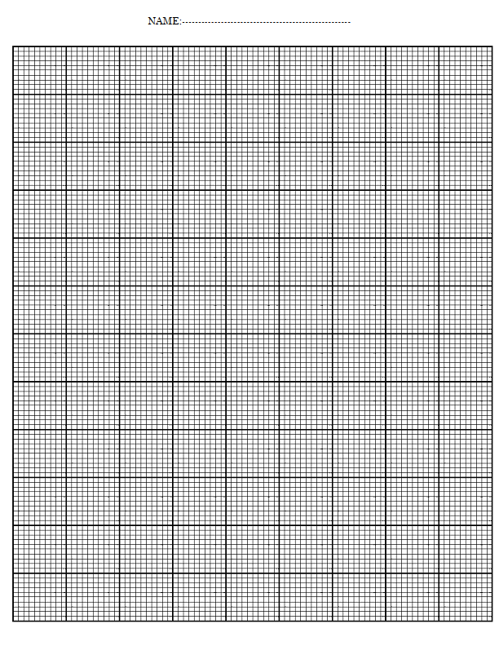
- Use your graph to find number of oscillations when the mass is 120 g
- 9 oscillations (1 mark)
4. a) -It has lower freezing point
It has a wide temperature range (2 marks)
b) Explain the importance of each of the following features in a liquid in glass thermometer.
i. -to prevent liquid column breakage.(1)
-to enable maximum temperature measurement.(1)
- It allows for easy reading. (1)
any two from above(2 marks)
ii. -liquid expansion (1)
-Increases sensitivity (1)
(2 mark)
c) -Thermocouple thermometer (1)
-Constant volume gas thermometer (1)
(2 marks)
d) kelvins ═ ºc + 273
ºc ═ Kelvins – 273
ºc ═ 4321- 273 (1)
ºC═ 4048 (1)

(2 marks)

5. (a) i.Matter is made up of tiny discrete individual particles that are continuously in motion (1mark)
ii. The heat increases molecular motion and the molecules start moving faster. (1)The molecules overcome intermolecular forces.(1) The solid wax changes to liquid as intermolecular forces weakens (2marks)
b. The kinetic theory state that molecules are in constant random motion. (1)The smell of the groundnuts spread through the process of diffusion. (1)Diffusion is the moving of particles from a region of high concertation to a region of low concertation.(1) The smell of groundnuts is high near the student and lower near the teacher (1) ( 4 marks)
6. a) When a body is wholly or partially immersed in fluid it experiences an upthrust which is equal to the weight of the fluid displaced (1mark)
b) –volume = area x height( v = Ah) (1)
-density = mass/volume.
Making mass subject:
Mass = density(d) x volume(Ah) (1)
- force(weight) = mass x gravity(g)
Force = dAhg (1)
- pressure(p) = $\frac{force}{Area}$ (1)

p = $\frac{dAhg}{A}$

P = dhg (1)
(5 marks)
c. -Water supply system(1) reserviour are constructed at high grounds to increase pressure onto the consumers taps.(1)
-Construction of dams(1) ; walls are thicker at the bottom than at the top(1)
(4 marks)
d. area of small piston(a)= πr²
= 3.14 x 2cm x 2cm(1)
Area of a large piston (A)= 3.14x 20cm x 20cm(1)
Ratio of A/a = 100 (1)
Since ratio of A/a F/f and f= 350N
Therefore F = 350N x 100 (1)
= 35,000N (1) (5 marks)
Section B (30 marks)
Answer all questions
7. a)
Hole 3
Hole 2
Hole 1

Fill the container with liquid and make 3 holes at different height. The water oozing out through the top hole makes short horizontal distance followed by the middle hole and then the bottom hole. This is because there id high pressure at the bottom hole as compared to top hole. This is the reason why the horizontal distance is greater at the bottom hole than the top hole.
(6 marks)
b.-Contact area
-Normal reaction (weight) (4 marks)
8.
- Immerse the thermometer in the container filled with ice (1)and wait for the mercury to stabilise (1)
- Mark the lower fixed point (1)
- Boil the water until (1)it reaches the boiling point (1)
- Immerse the thermometer in the boiling water and wait until it stabilizes(1)
- Mark the upper fixed point(1)
- Divide the distance in to 100 equal distance using the ruler(1)
- Mark the lower fixed point as 0 and upper fixed point as 100 (1)
(10 mark)

9. Aim : To find out how surface area affect rate of cooling (1)
Materials
Stop watch
3 beakers of different size
Thermometer
Water
Measuring cylinder
-(three correct points (1)/ At least four correct points (2)

Procedure
- Measure certain amount of hot water using a measuring cylinder(1) and pour it in a small beaker of 100 cm³(1)
- Start the stop watch and wait until the temperature degrees by 10ºc (1)
- Record the time in the table of results (1)
- Repeat 1, 2 and 3 for 200 and 300 cm³ (1)

Conclusion
The bigger the surface area(1) the higher the rate of cooling (1)/
When the surface area increases(1) the time taken to cool is reduced (1)
(10 marks)

